EduGenie: Google Gemini Powered Learning Assistant

Introduction
EduGenie is an AI-based educational assistant developed to help students understand topics, get answers, practice through quizzes, summarize study materials, and get learning recommendations. Designed for students of all academic levels, EduGenie enables users to:
- Ask questions and receive smart, concise answers
- Understand complex concepts through simplified explanations
- Generate quizzes from topics or text
- Receive personalized learning recommendations
- Summarize large educational passages

Problem Statement
Students often find it difficult to understand complex topics, get quick answers, practice questions, revise study materials, and decide what to learn next.
To solve these problems, we developed EduGenie.
Objective
The main objective of our project is to provide multiple learning features in a single AI-powered platform. Like,
- Question and Answer
- Concept Explanation
- Quiz Generation
- Text Summarization
- Learning Path Recommendation

Architecture
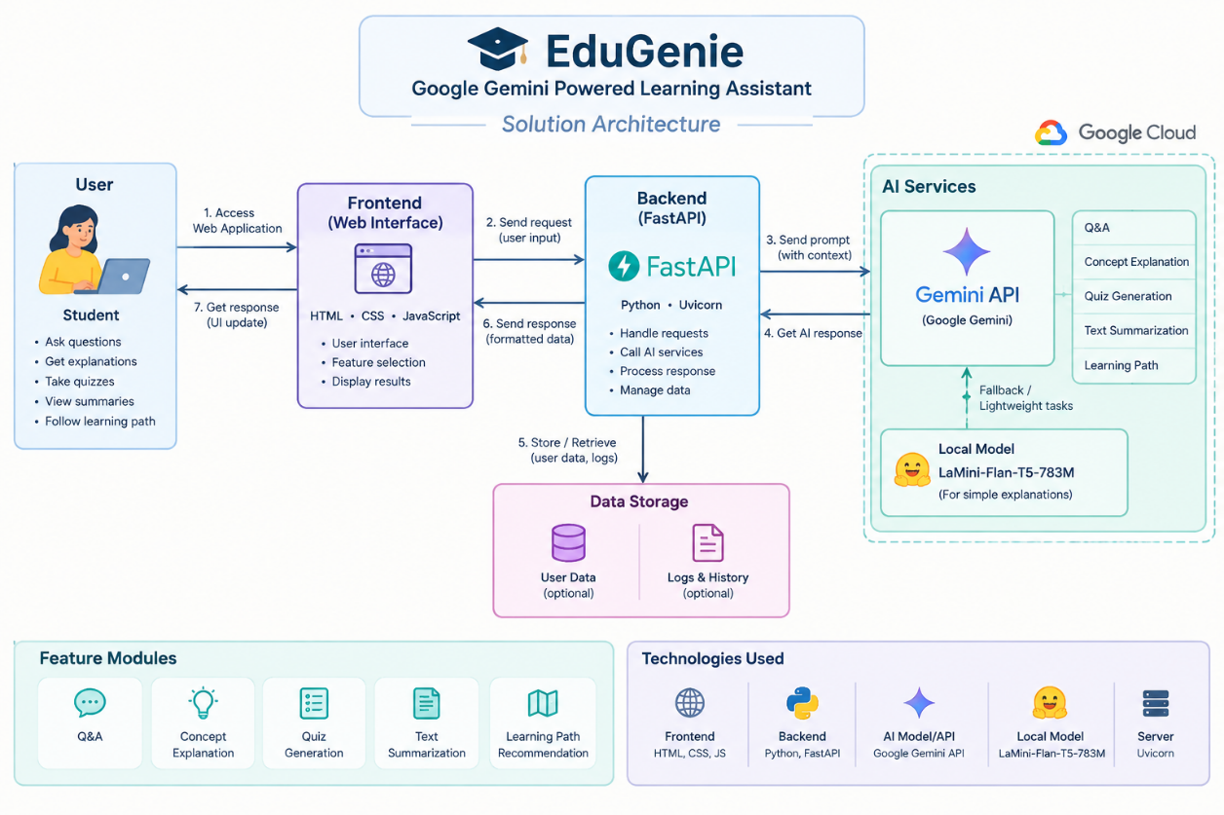

Pre-requisites
1. Python 3.10+
Python is required for developing and running the EduGenie backend application. In this project, Python is used to implement the FastAPI backend and integrate the AI services.

2. FastAPI Framework
FastAPI is used to develop the backend APIs of the EduGenie application. It handles user requests, processes inputs, and communicates with the Google Gemini API.
3. HTML & CSS
HTML and CSS are used to create the frontend interface of the application. HTML provides the structure of the web pages, while CSS is used for styling and layout.
4. Google Gemini API Key
A Google Gemini API key is required to connect the application with the Gemini AI model. The API is used to generate answers, explanations, quizzes, summaries, and learning path recommendations.
5. Uvicorn
Uvicorn is used as the ASGI server to run the FastAPI application locally.
6. Jinja2
Jinja2 is used as the HTML templating engine to connect the FastAPI backend with the HTML frontend templates.

Project Workflow
MILESTONE 1: Model Selection and Architecture
AI Models
Gemini 3.5 Flash Lite (via API):
Used for: Question and Answer, Concept Explanation, Quiz Generation, Text Summarization, and Learning Path Recommendation.
Benefits: Provides fast AI-generated responses and supports multiple educational tasks through cloud-based inference.
LaMini-Flan-T5-783M (Local):
Used for: Concept Explanation.
Status: Included as an optional local explanation model, but currently disabled in the project configuration.
Benefits: Lightweight and suitable for local inference.

Folder Architecture:
EduGenie/
- main.py # FastAPI app
- explanation_module.py # Concept explanation logic
- qna.py # Question answering
- quiz_module.py # Quiz generation
- summary_module.py # Summarization
- learning_path.py # Learning recommendations
- templates/index.html # HTML frontend
- static/style.css # Styling
- requirements.txt # Python dependencies

Epic 2: Core Functionalities Development
Activity 2.1: Module Implementation
1. Explanation Module
The Explanation Module helps students understand difficult topics in simple language. It uses the Google Gemini 3.5 Flash Lite model to generate clear and easy-to-understand explanations based on the topic given by the student. This feature is useful for students who need quick explanations while learning.
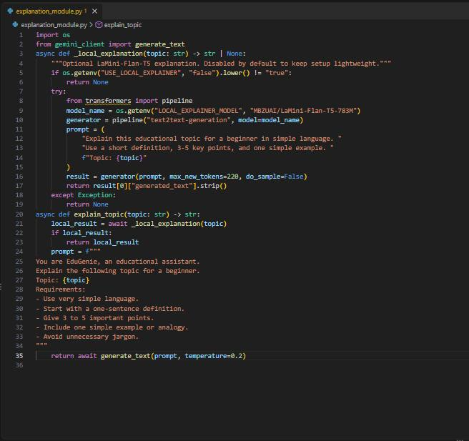

2. QnA Module
The QnA Module allows students to ask questions related to their studies. The question is sent from the frontend to the FastAPI backend, which communicates with the Google Gemini API. Gemini generates the answer and the response is displayed on the frontend. This helps students get quick answers to their doubts.
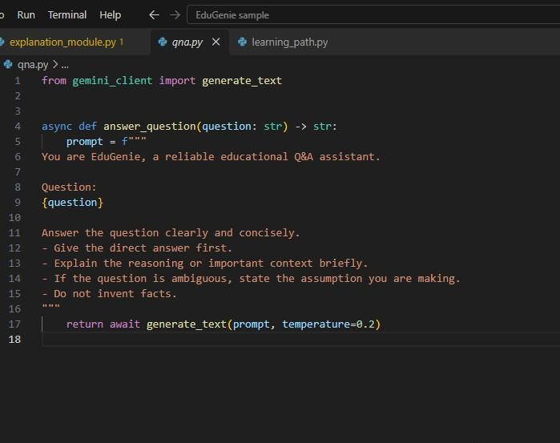
3. Quiz Module
The Quiz Module generates multiple-choice questions (MCQs) based on the topic or content provided by the student. The Gemini model processes the given input and generates relevant questions with answer options. This feature helps students practice and check their understanding of a topic.
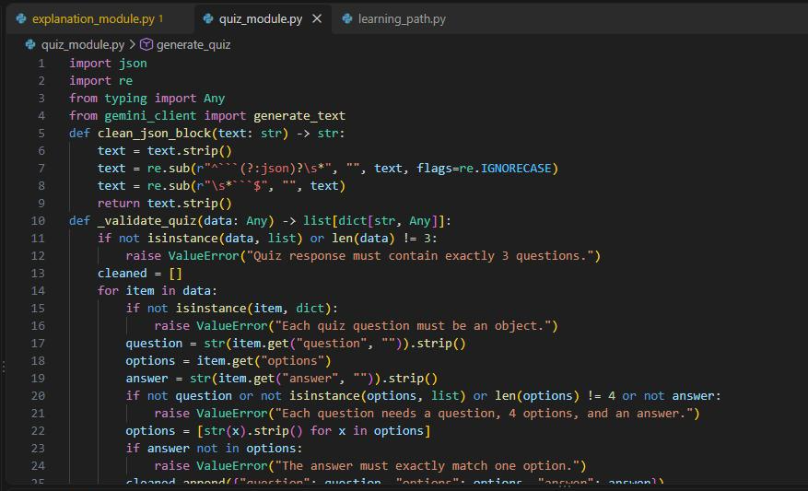

4. Summary Module
The Summary Module helps students revise long study materials quickly. It sends the given content to Gemini and generates a short and meaningful summary while keeping the important information. This makes revision easier and saves time.
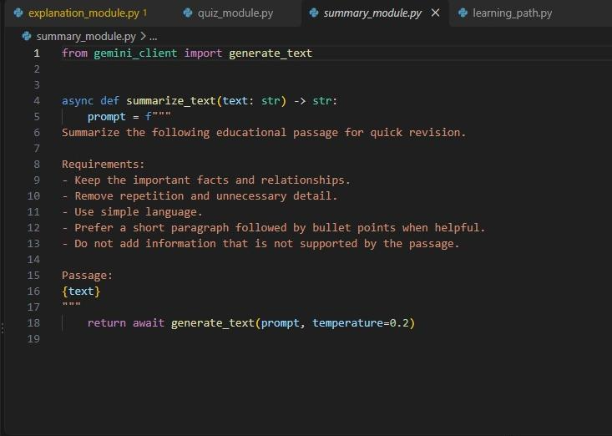
5. Learning Path Module
The Learning Path Module provides a step-by-step learning path for a selected topic. Gemini generates learning recommendations starting from basic concepts and gradually moving towards advanced concepts. This helps students understand what they should learn first and what they can learn next.
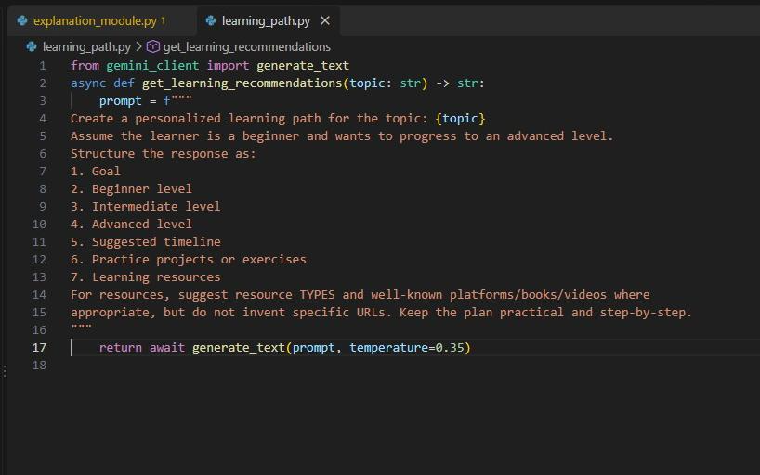
Activity 2.2: Backend API with FastAPI
FastAPI is used to create the backend APIs for the EduGenie application. Separate endpoints are created for each main feature. Each endpoint connects the user request to the corresponding module and returns the generated response.
API Endpoints
- /qa – Handles Question and Answer
- /explain – Handles Concept Explanation
- /quiz – Generates Quiz Questions
- /summarize – Summarizes study content
- /learn/recommendations – Generates Learning Path Recommendations
The backend receives the input from the frontend, sends it to the required module, and returns the result to the user interface.
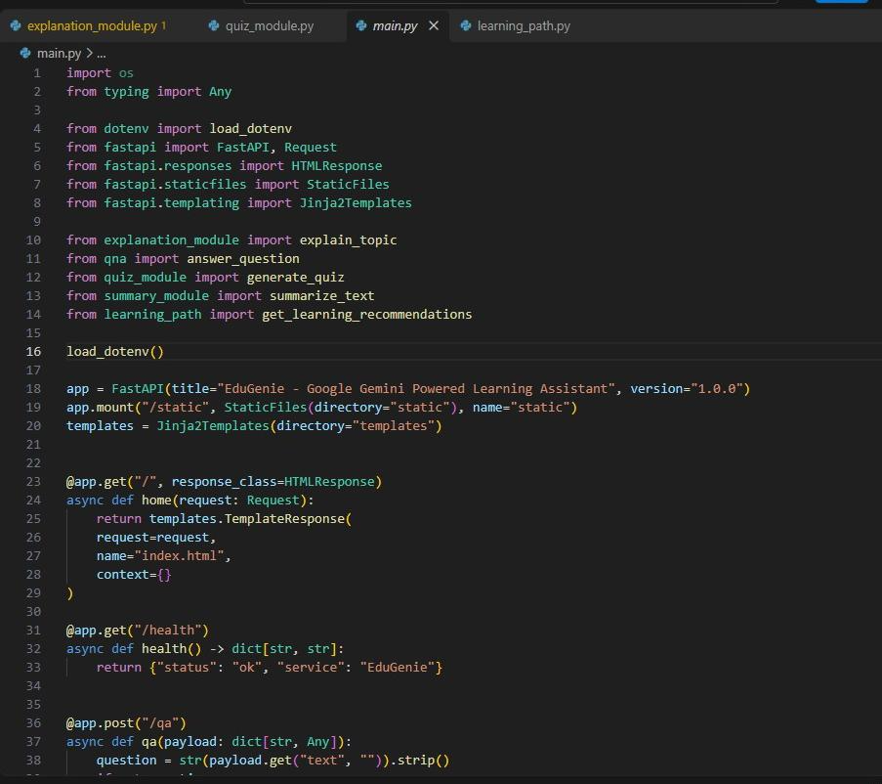
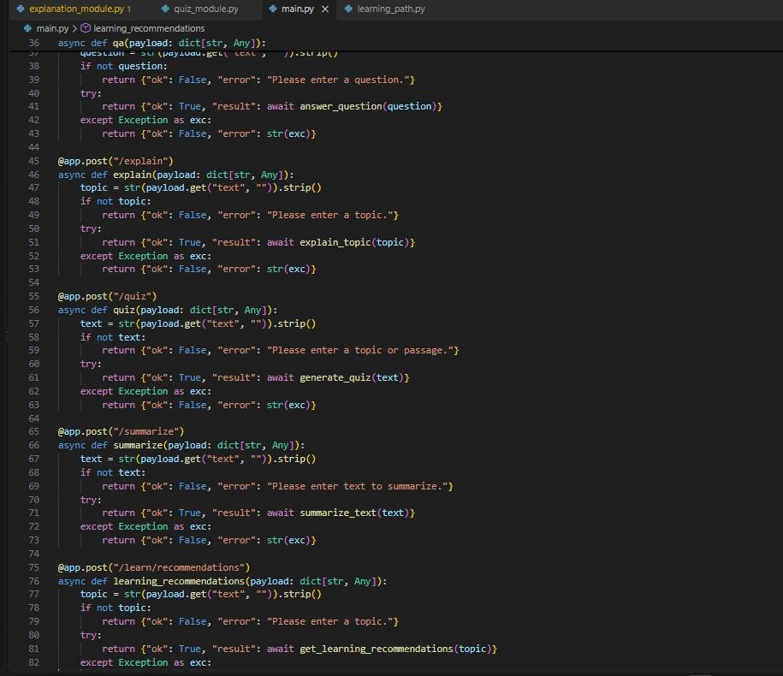
Epic 3: Frontend Development
Activity 3.1: Build Web Interface
HTML Form (index.html)
The EduGenie frontend is designed using HTML to provide a simple and user-friendly interface. The form contains the following options:
- Task Dropdown: Explain, QnA, Quiz, Summary, Recommend Path
- Text Area: Allows students to enter their question or study content.
- Submit Button: Sends the entered input to the backend for processing.
- Result Container: Displays the generated AI response.

CSS Styling (style.css)
CSS is used to improve the appearance and usability of the web interface. The design includes:
- Responsive layout for different screen sizes
- Styled buttons and input areas
- Clear task selection
- Proper spacing and alignment
- Separate result container for displaying responses

Activity 3.2: Live Integration
The frontend is connected to the FastAPI backend for live processing. When the student selects a task, enters the required input, and clicks the Submit button, the frontend sends a POST request to the corresponding FastAPI endpoint.
The backend processes the request using the selected EduGenie module and Google Gemini 3.5 Flash Lite. The generated response is then returned to the frontend and displayed below the input area.

Epic 4: Deployment
Activity 4.1: Run Locally
The EduGenie application is deployed and tested on a local system using Uvicorn, an ASGI server for running the FastAPI application.
The application can be started using:
python -m uvicorn main:app --reload
After starting the server, the application can be accessed through the browser at:
http://127.0.0.1:8000

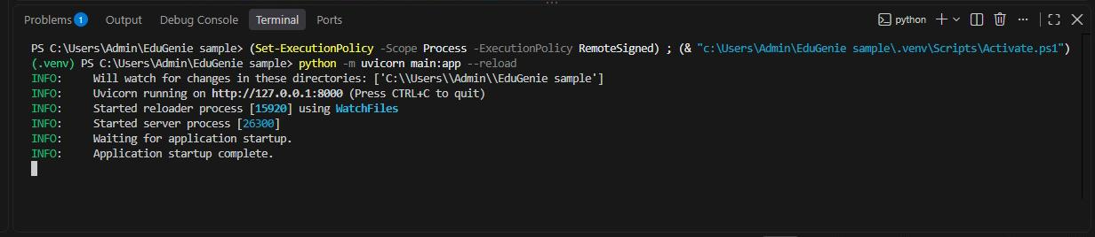
Activity 4.2: Functional Testing
Functional testing is performed to verify that all major EduGenie features work correctly. The following functions are tested:
- Ask a Question – Enter a question and receive an AI-generated answer.
- Get an Explanation – Enter a topic and receive a simple explanation.
- Generate a Quiz – Enter a topic and generate quiz questions.
- Summarize Content – Enter study content and receive a concise summary.
- Get a Personalized Learning Plan – Enter a topic and receive a step-by-step learning path.
These tests verify the connection between the frontend, FastAPI backend, feature modules, and Google Gemini API.
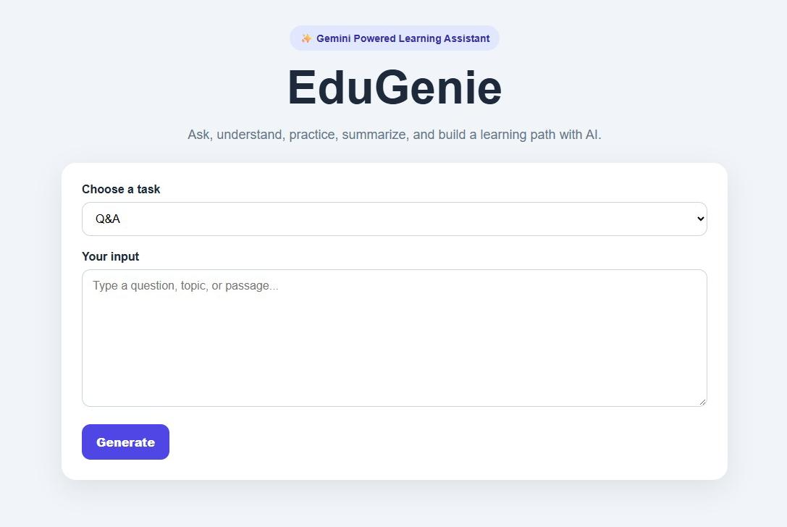

  - Ask a question
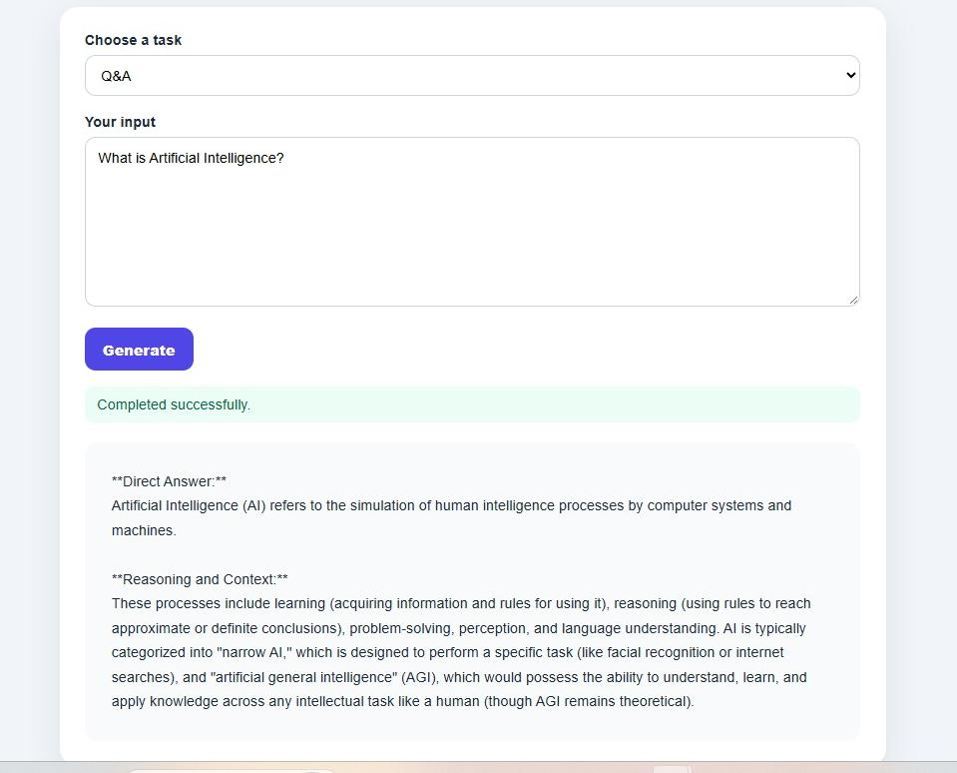
  - Explain a topic
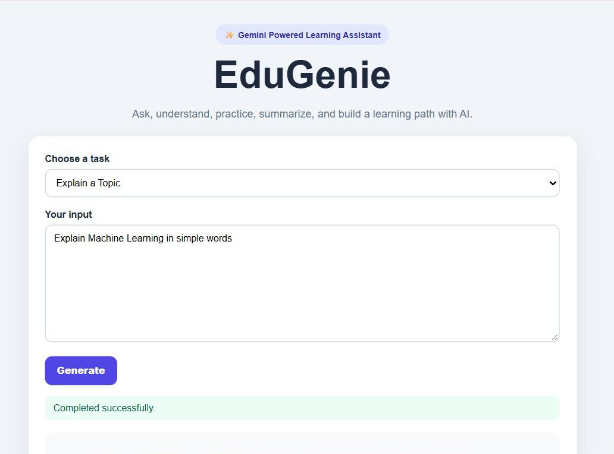
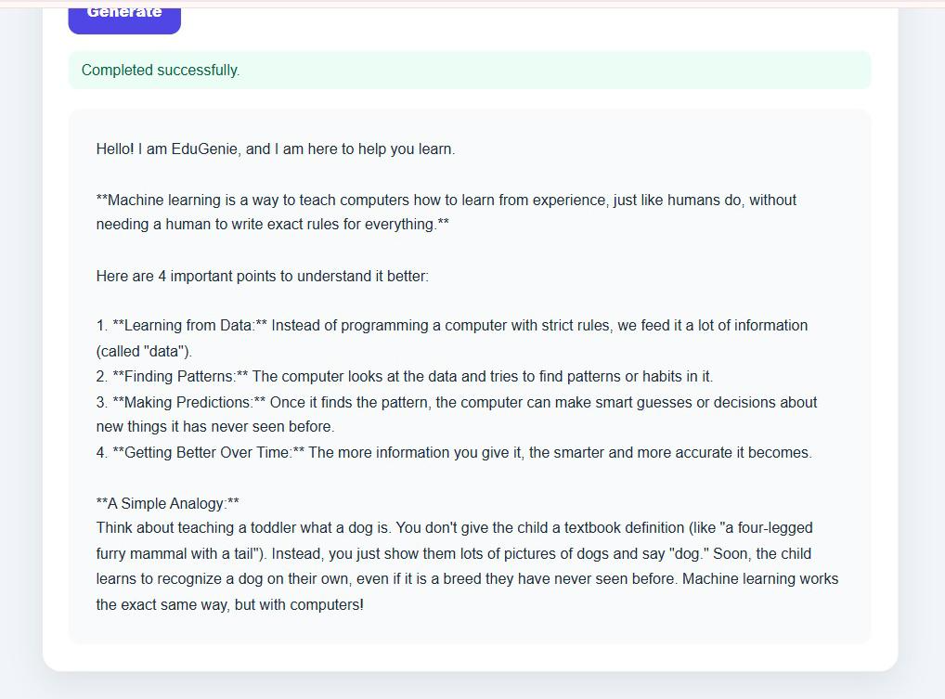
  - Generate a Quiz
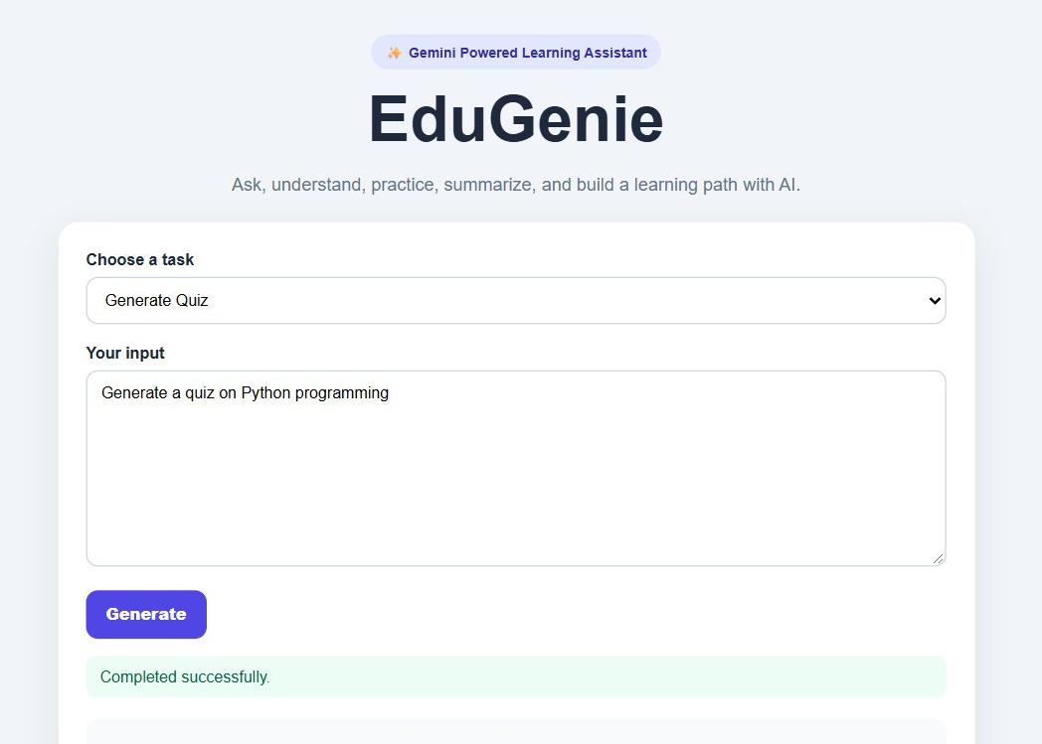
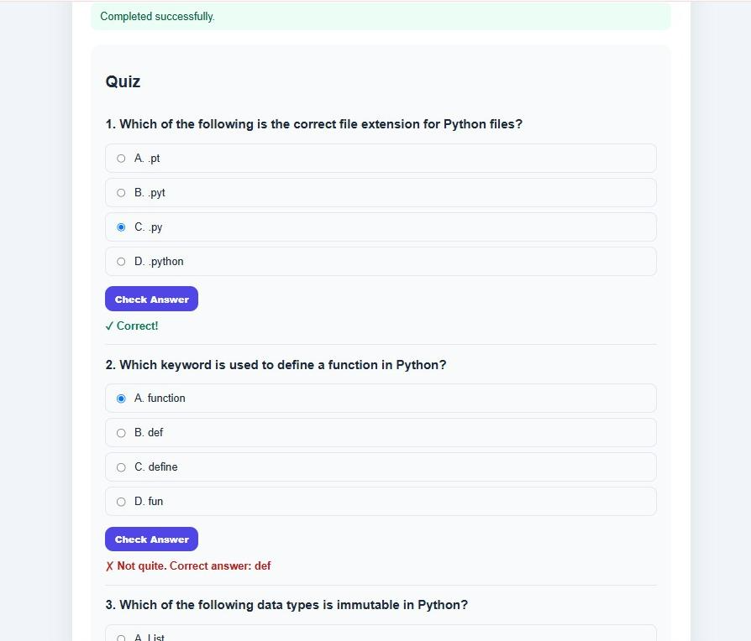
  - Summarize content
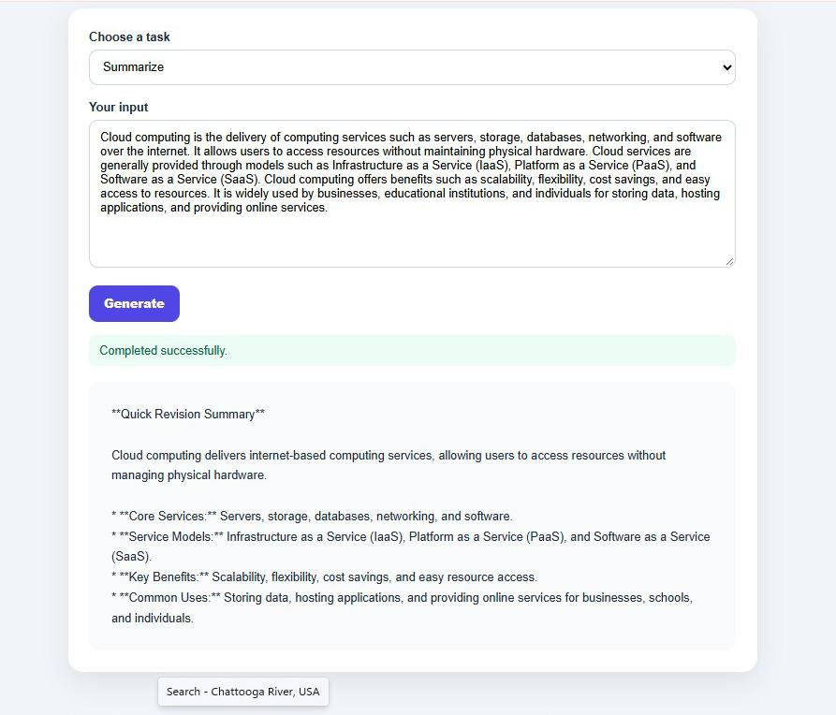
  - Get a personalised learning path
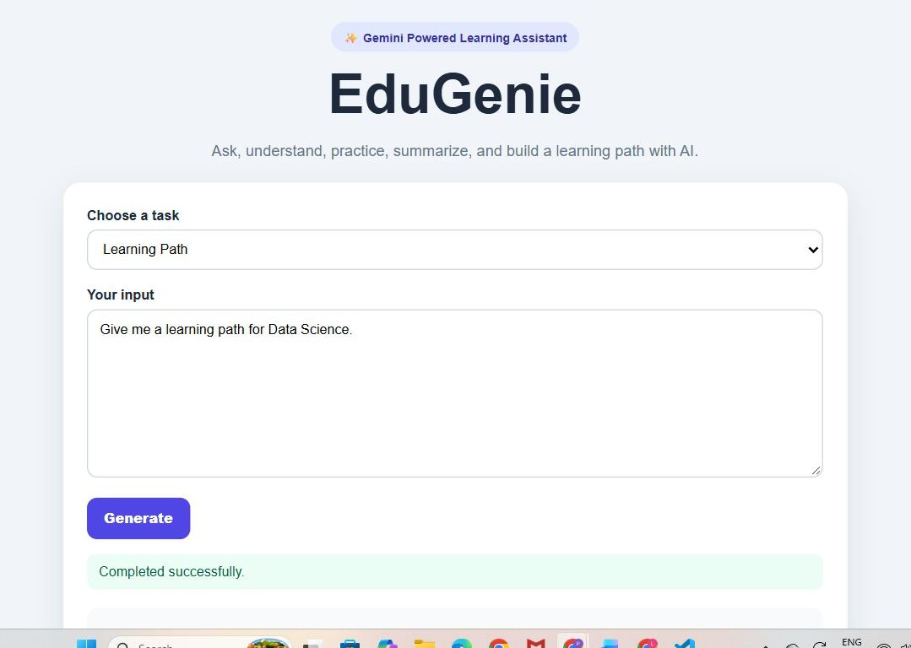

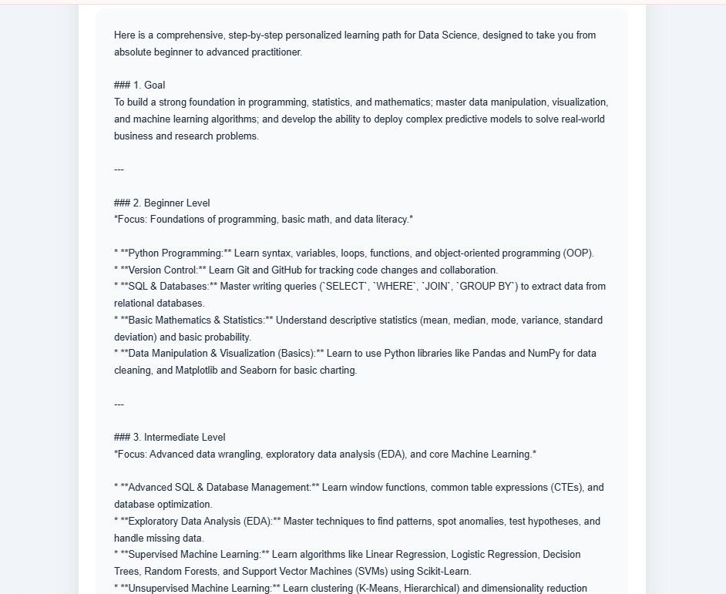
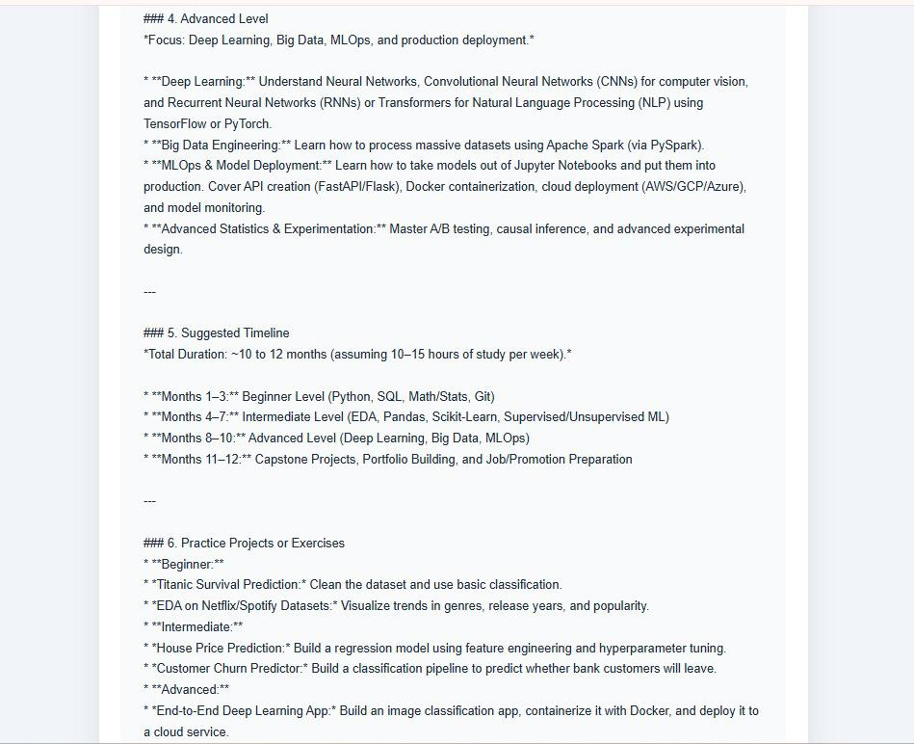

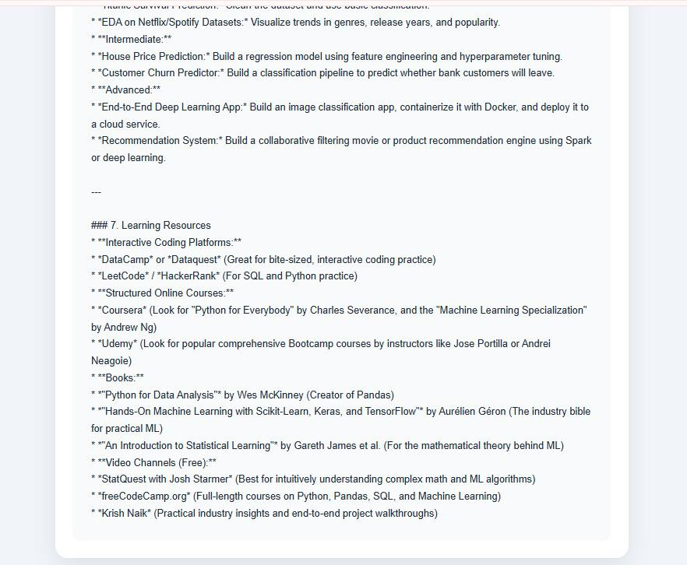

Conclusion
EduGenie has been developed as a lightweight AI-powered educational assistant that helps students learn in a simple and interactive way. The system provides Question and Answer, Concept Explanation, Quiz Generation, Text Summarization, and Personalized Learning Path features through a web-based interface.
The project uses HTML and CSS for the frontend, Python and FastAPI for the backend, and Google Gemini 3.5 Flash Lite for AI-based responses. The modular design makes it easy to maintain and add new features in the future.
During development, the project helped demonstrate the practical use of Generative AI, API integration, FastAPI, frontend development, prompt engineering, and system testing. The application was tested locally to verify the major functionalities.
In the future, EduGenie can be enhanced with voice interaction, multilingual support, mobile applications, progress tracking, gamification, image/PDF input, and adaptive learning features. These improvements can make the system more useful and accessible for students.
Overall, EduGenie provides a simple platform that brings multiple learning-support features together in one application and can be further developed into a more comprehensive AI learning assistant.

Submitted by,
Team ID: SWTID-2026-6471
Team Lead: Poojadevi M
Team Members: Nathiya C
Luvina R
Date: 03 /10/2026

